A PROJECT REPORT

On

“Procure-to-Pay(P2P) Cycle in SAP MM with Custom ABAP Report Simulation”
By

Student Name | PARANJAY SENAPATI
Roll Number | 2305145
Branch | Computer Science Engineering (CSE)
Program | SAP — Data Analytics & Engineering
Institution | Kalinga Institute Of Industrial Technology, Bhubaneswar
Academic Year | 2025–2026



SCHOOL OF COMPUTER ENGINEERING

KALINGA INSTITUTE OF INDUSTRIAL TECHNOLOGY

BHUBANESWAR, ODISHA - 751024

Abstract

The Procure-to-Pay (P2P) cycle is a key process in SAP Materials Management (MM) that manages procurement from material requirement to vendor payment. This project presents a simulation-based implementation of the P2P cycle using ABAP programming concepts, developed without access to a live SAP environment. Core stages—including purchase requisition, purchase order, goods receipt, invoice verification, and payment—are modeled using ABAP internal tables and structured logic. A custom report, ZP2P_TRACKING_REPORT, integrates all stages and provides a consolidated view of procurement transactions, demonstrating SAP MM workflow and ABAP logic for academic application.

Project Overview

The Procure-to-Pay (P2P) cycle is a core process in SAP Materials Management (MM) that manages procurement from material requirement to vendor payment. This project presents a simulation of the P2P cycle using ABAP programming logic, developed without access to a live SAP system. Key stages—including purchase requisition (PR), purchase order (PO), goods receipt (GR), invoice, and payment—are modeled using ABAP internal tables and modular programs to ensure structured data flow. The central component is a custom report, ZP2P_TRACKING_ REPORT, which integrates all stages and provides a consolidated view of procurement transactions.

Problem Statement
Procurement in modern organizations involves multiple stages such as purchase requisition, purchase order creation, goods receipt, invoice verification, and payment processing. Without proper system integration, managing these stages can lead to inefficiencies, delays, data inconsistencies, and lack of transparency in tracking transactions. Manual or disconnected systems further increase the risk of errors such as delayed approvals, mismatched records, and incomplete payment tracking, affecting overall operational efficiency. Although SAP Materials Management (MM) provides a structured Procure-to-Pay (P2P) process, access to live SAP systems is often limited in academic environments. To address this limitation, this project proposes a simulation-based approach using ABAP programming logic to model the P2P cycle and track procurement activities through a custom report.

Objectives
The main objectives of this project are:
- To understand the Procure-to-Pay (P2P) lifecycle in SAP Materials Management (MM).
- To simulate key procurement stages such as PR, PO, GR, invoice, and payment.
- To implement ABAP-based logic using internal tables and structured programming.
- To develop modular programs for different procurement stages.
- To create a custom report ZP2P_TRACKING_REPORT for end-to-end tracking.
- To demonstrate SAP workflow simulation without a live SAP system.

Scope of the Project
This project focuses on simulating the Procure-to-Pay (P2P) cycle in SAP Materials Management (MM) using ABAP programming concepts. The implementation models the core procurement workflow through structured data and modular design without using a live SAP system.
The project covers the following key components:
• Vendor Master Simulation • Material Master Simulation
• Purchase Requisition (PR) • Purchase Order (PO)
• Goods Receipt (GR) • Invoice Verification
• Payment Status Tracking • Final P2P Tracking Report
Each component is implemented using ABAP internal tables and structured logic to ensure proper data flow across all stages. The project is simulation-based and designed for academic demonstration of SAP workflow and ABAP programming.

Procure-to-Pay (P2P) Process Overview:
The Procure-to-Pay (P2P) cycle is a key process in SAP Materials Management (MM) that manages the end-to-end procurement lifecycle, from requirement identification to vendor payment. It ensures a structured and integrated flow of procurement activities within an organization.
The P2P process includes the following stages:
- Purchase Requisition (PR):
Initiates the procurement process by capturing internal requirements for materials or services.
- Purchase Order (PO):
A formal document issued to the vendor specifying material details, quantity, pricing, and delivery terms.
- Goods Receipt (GR):
Confirms the receipt of materials from the vendor and updates inventory records.
- Invoice Verification:
Ensures that the vendor invoice matches the purchase order and goods receipt details.
- Payment Processing:
Processes the vendor payment after successful invoice verification and updates the payment status.
- Final Tracking Report:
Provides a consolidated view of all procurement stages, enabling effective monitoring of transactions.
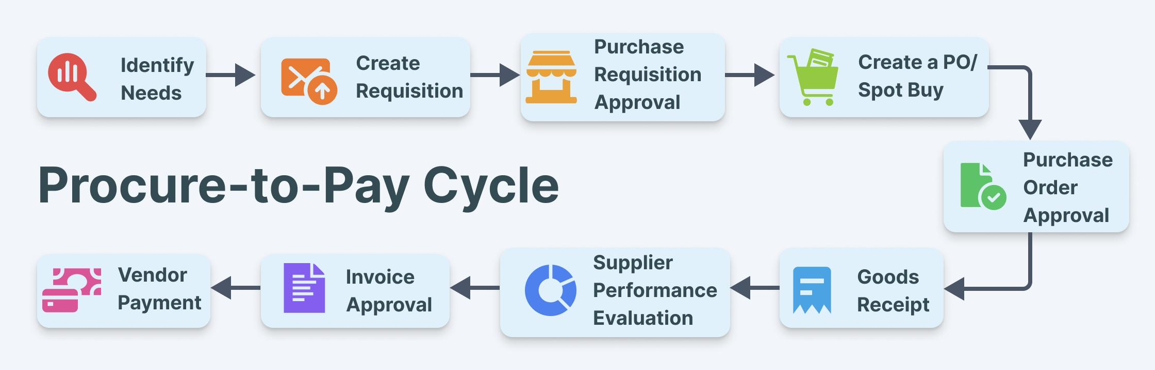
Proposed SAP Tables and Simulation Logic: In SAP Materials Management (MM), the Procure-to-Pay (P2P) cycle is supported by interconnected tables that manage vendor, material, and procurement data. In this project, these standard SAP tables are conceptually referenced and simulated using ABAP internal tables due to the absence of a live SAP environment.
Key SAP Tables Referenced:
•LFA1:Vendor Master Data •MARA: Material Master Data
•EBAN:Purchase Requisition •MKPF/MSEG: Goods Receipt
•EKKO/EKPO:Purchase Order(Header&Item) • RBKP/RSEG: Invoice Receipt
These tables are logically represented using ABAP structures and internal tables to simulate data flow across different stages of the P2P process.

Simulation Logic in the Project
Due to the absence of a real SAP database, the project simulates the above tables using ABAP constructs. The simulation logic is implemented as follows:
- Internal Tables: Each SAP table is represented using ABAP internal tables to store data dynamically during program execution.
- Custom Data Structures: ABAP TYPES and work areas are used to define the structure of each business object such as vendor, material, purchase requisition, and purchase order.
- Data Linking Mechanism: Relationships between different procurement stages are maintained using common keys such as:
• Vendor ID • Material ID • PR Number
• PO Number • Invoice Number

•Sequential Data Flow: Data flows logically from one stage to another, replicating the real SAP P2P process.
- Report Integration: All simulated data is combined in the final ABAP report to provide a consolidated view of the procurement lifecycle.

Significance of Simulation Approach
The simulation approach allows the project to:
- Demonstrate SAP MM workflow without system access
- Provide practical understanding of data relationships
- Enable implementation of ABAP logic in a structured manner
- Bridge the gap between theoretical knowledge and real-world SAP systems
System Design: The system design represents a structured flow of data across different stages of the Procure-to-Pay (P2P) cycle. Although simulation-based, it follows the logical architecture of SAP Materials Management (MM) systems. The design is modular, where each procurement stage is implemented independently and integrated into a final reporting layer, ensuring consistent data flow and clear separation of functionalities.

Architecture Overview: The conceptual architecture of the system consists of three main layers:

Input Layer :This layer represents the initial data required for procurement activities. It includes:

• Vendor Master Data • Material Master Data

• Purchase Requisition Data
These inputs form the base for further processing in the procurement cycle.

2. Processing Layer
This layer handles the transformation and flow of data through different stages of the P2P cycle. It includes:
• Purchase Order Creation • Goods Receipt Processing
• Invoice Verification • Payment Status Tracking
Each stage processes data from the previous step and passes it to the next stage, maintaining logical continuity.
3. Output Layer
This layer is responsible for presenting the final consolidated information. It includes:
- Custom ABAP Report (ZP2P_TRACKING_REPORT)
The report integrates all procurement stages and provides a complete view of transaction status.
Data Flow Design:
The data flow in the system follows a sequential pattern:
Material Requirement → Purchase Requisition → Purchase Order → Goods Receipt → Invoice Receipt → Payment Status → Final Report
Each stage is connected through unique identifiers such as PR number, PO number, and invoice number, ensuring accurate mapping of procurement transactions.
Modular Design Approach
The system is divided into multiple modules, each representing a specific stage of the procurement process:
- Vendor Module • Material Module
- Purchase Requisition Module • Purchase Order Module
- Goods Receipt Module • Invoice Module
- Payment Module • Reporting Module
This modular approach improves clarity, maintainability, and ease of understanding.

Advantages of the Design
- Ensures clear separation between different procurement stages
- Allows easy tracking of data across modules
- Simplifies debugging and enhancement
- Provides a scalable structure for future improvements
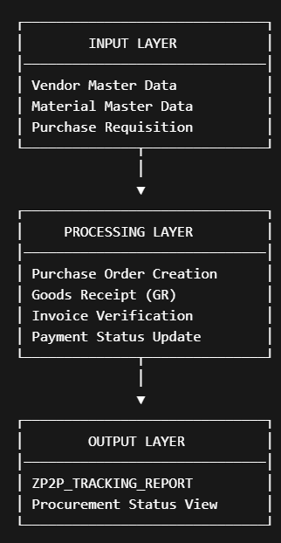

Folder Structure for Submission
SAP_P2P_Capstone/
│
├── 01_Project_Overview.txt
├── 02_P2P_Process_Explanation.txt
├── 03_ABAP_Vendor_Master.txt
├── 04_ABAP_Material_Master.txt
├── 05_ABAP_PR_Creation.txt
├── 06_ABAP_PO_Creation.txt
├── 07_ABAP_Goods_Receipt.txt
├── 08_ABAP_Invoice_Receipt.txt
├── 09_ABAP_Payment_Status.txt
├── 10_ABAP_Final_Report.txt
├── 11_Sample_Data.txt
├── 12_Expected_Output.txt
└── Project_Report.txt
Implementation
The project is implemented as a simulation of the Procure-to-Pay (P2P) cycle using ABAP programming logic due to the absence of a live SAP system. It is structured into modular components representing key stages such as vendor, material, purchase requisition (PR), purchase order (PO), goods receipt (GR), invoice verification, and payment tracking.
Each module uses ABAP internal tables and structured logic to process data, with common keys ensuring consistent data flow across stages. The central component is the custom report ZP2P_TRACKING_REPORT, which integrates all modules and generates a consolidated view of procurement transactions.

Result
The simulated output successfully demonstrates the integration of procurement stages. For example, the report shows that one purchase order has completed payment while another is still pending. This helps track document flow and business status.
The project proves that even without direct SAP access, a meaningful SAP MM capstone project can be developed using correct process knowledge and ABAP logic design.
Conclusion
This project successfully simulates the Procure-to-Pay cycle in SAP MM using ABAP-based logic. It covers the main steps of procurement and provides a final custom report for transaction tracking. The project is academically valuable because it reflects real SAP business flow, demonstrates ABAP programming knowledge, and remains practical for students without access to enterprise SAP systems.
In future, this prototype can be enhanced by adding approval workflow, stock validation, ALV report output, vendor selection logic, and integration with finance simulation for automatic payment posting.

Screenshots:
Material Master

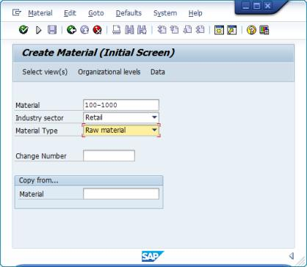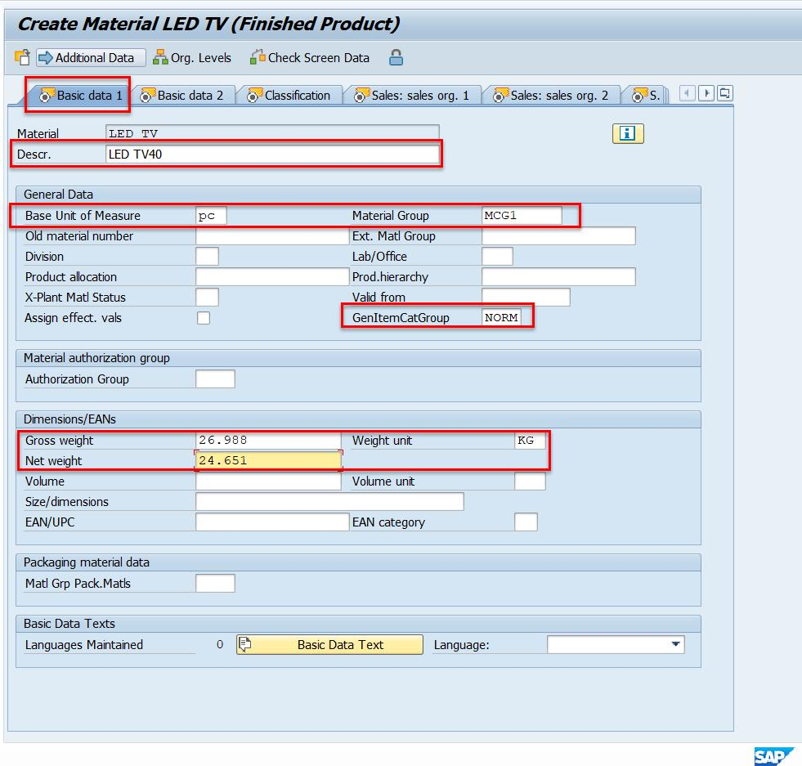

Vendor Master
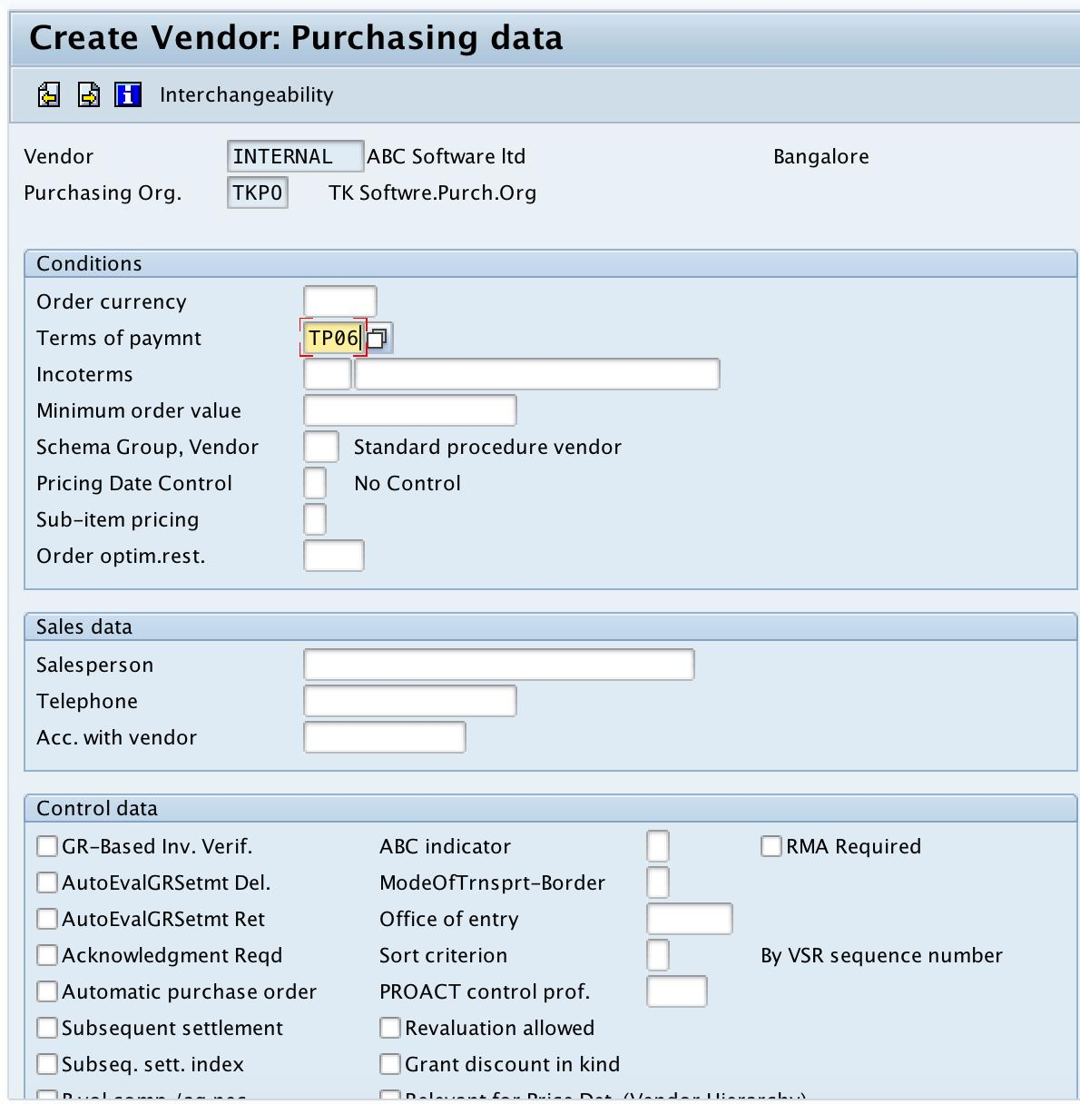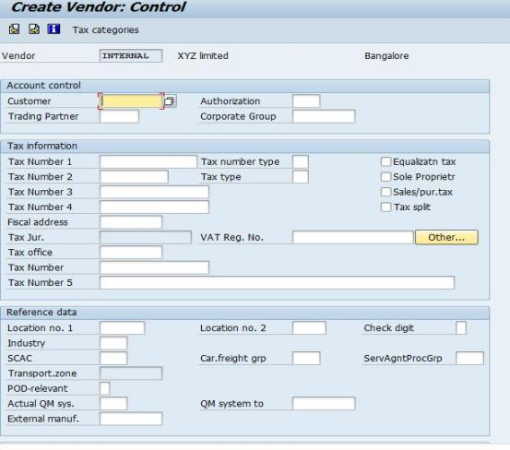

PURCHASE ORDER Invoice

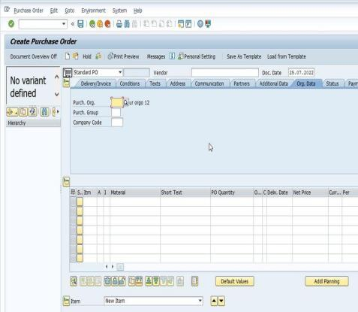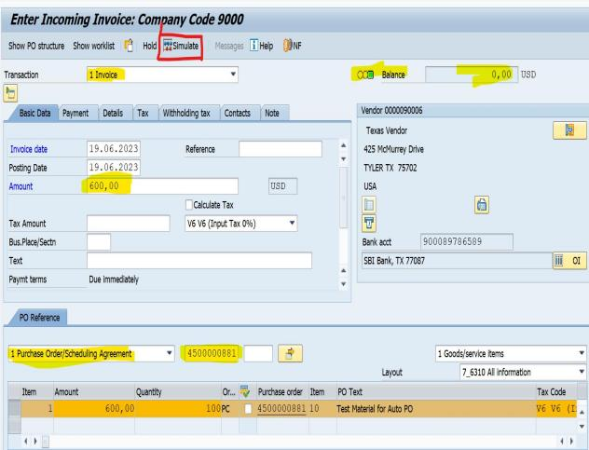

Goods Receipt

